ALE Interview Questions:

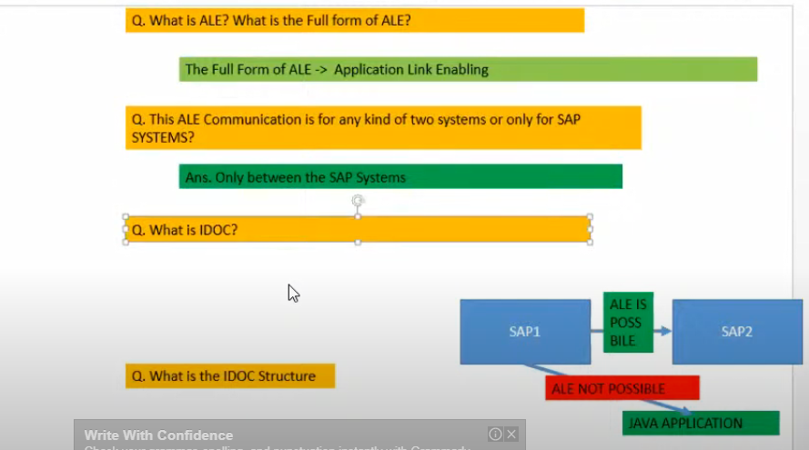

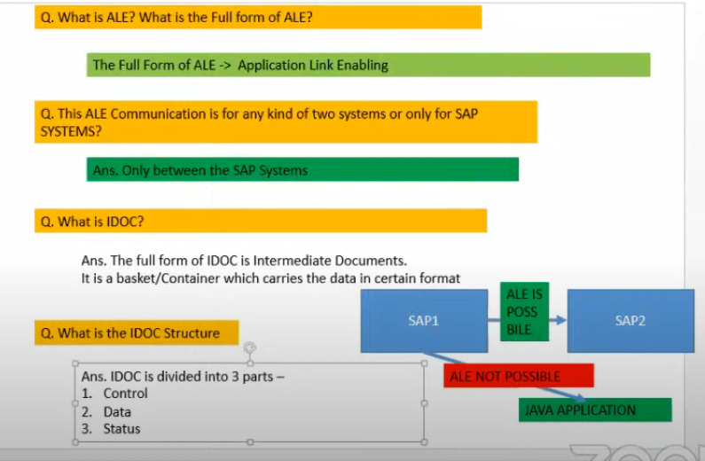

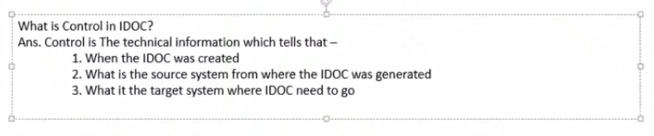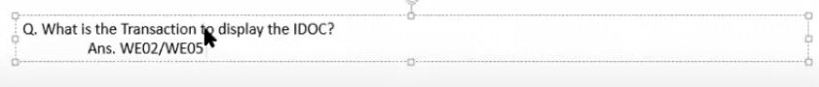

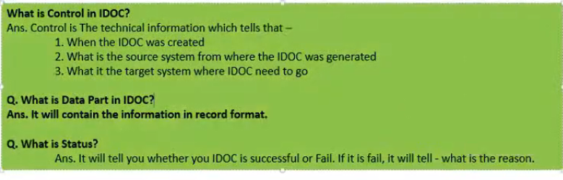

We09: TO SEARCH THE IDOC

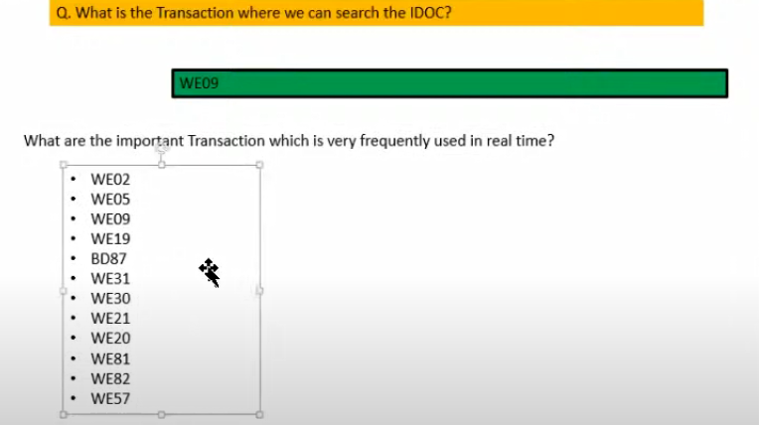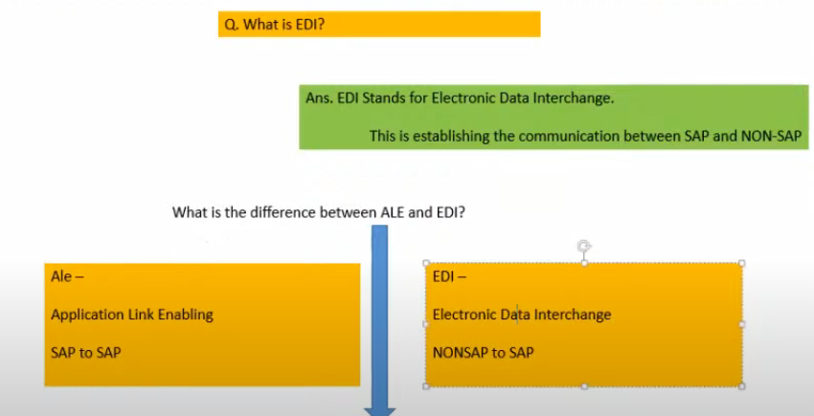

Process code is identifying IDOC based upon the message types.

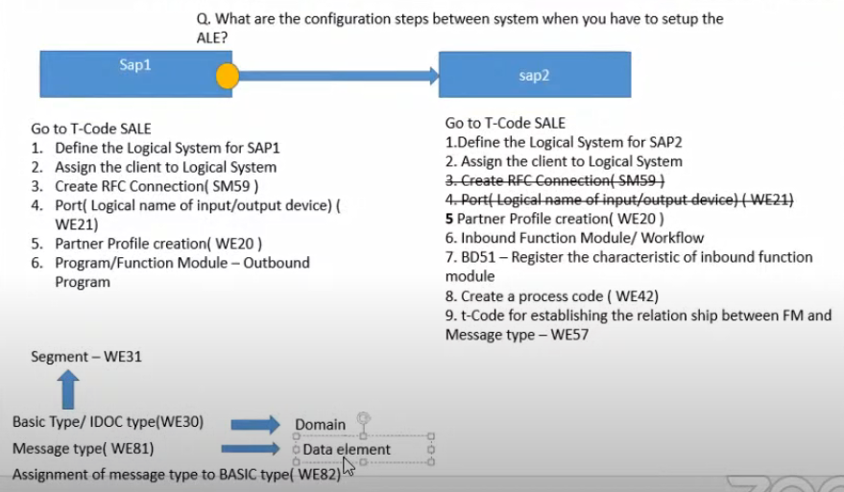

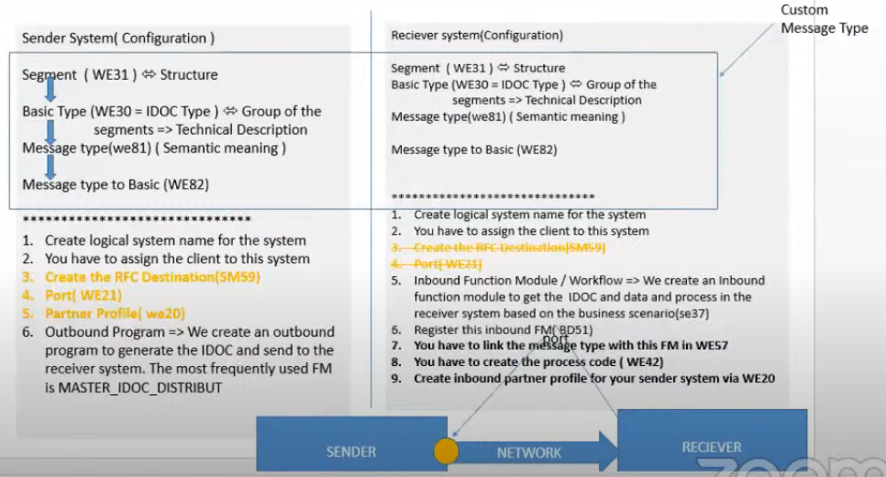

BD64 not required if you are port and partner profile creation, if it is not you can go with BD64 🡪 it is automatically creating the port and partner profile.

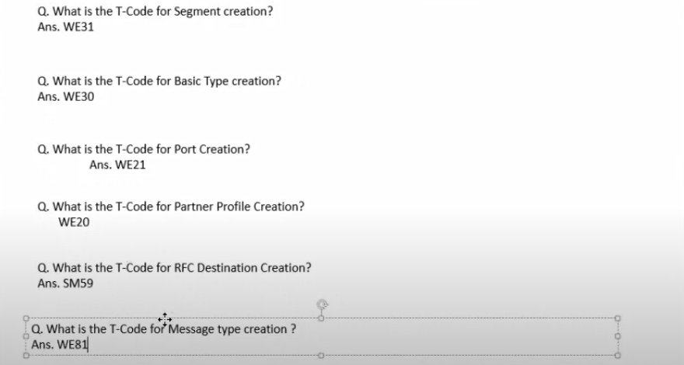

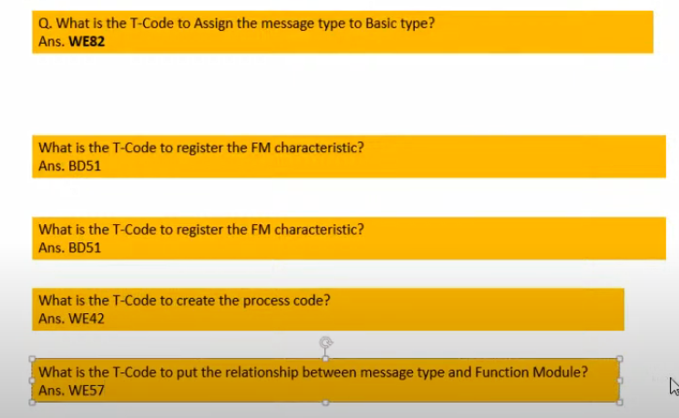

WE57 : is very important in INBOUND to identify the inbound FM.

How many ways to send

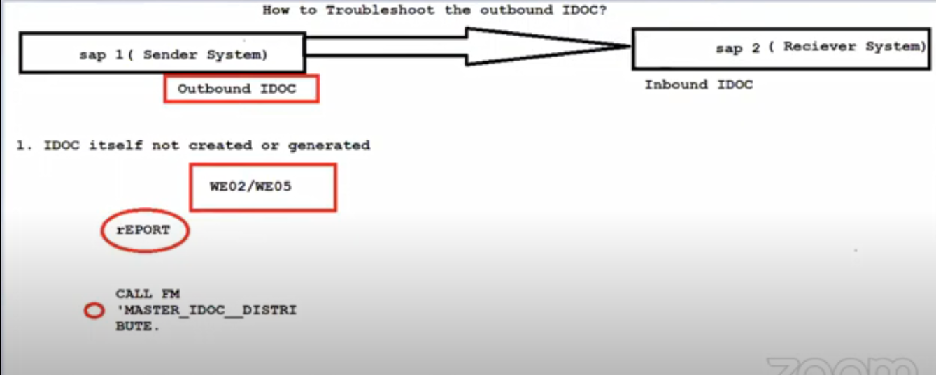

1. Custom IDOC🡪 SE38 🡪MASTER_IDOC_DISTRIBUTE
2. Message Control : NACE
3. Change pointers

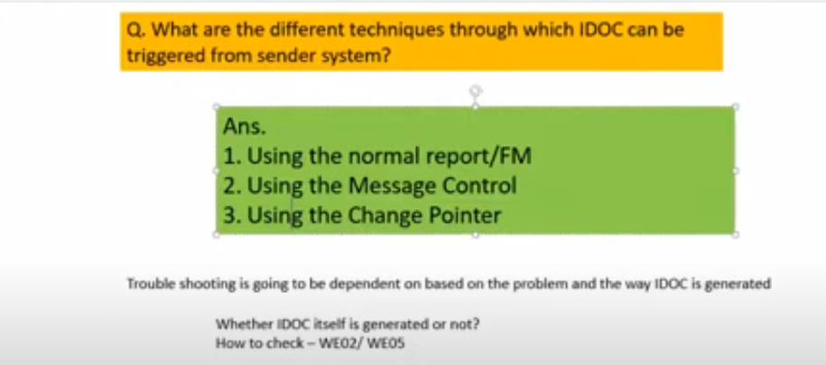

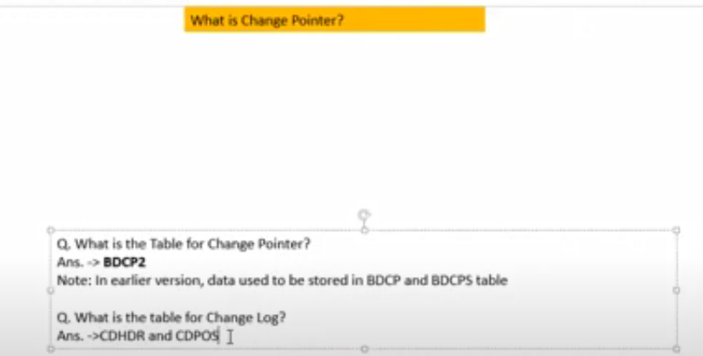

<https://www.youtube.com/watch?v=gSJZjI95ZMg> : 35:00

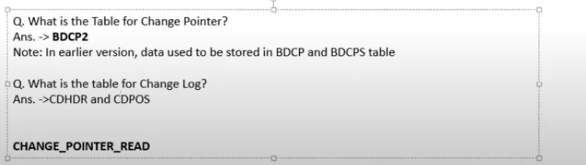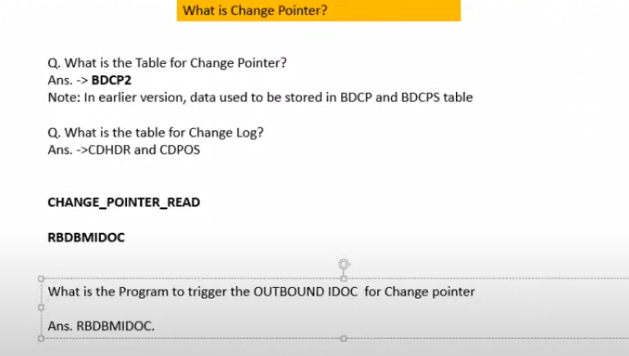

BD87:

* Sometime you are not able to find outbound program and you know the IDCO/you don’t know what is the transaction also, in this case go and try with BD87.
* Go to BD87
* Give the IDOC NO in BD87🡪 Here it is the error status, we can reprocess from BD87, and debug it .
* BD87 only help from MESSAGE CONTROL Idocs
* 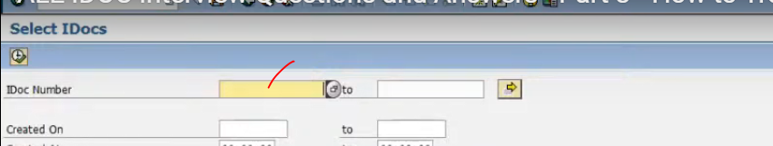
* 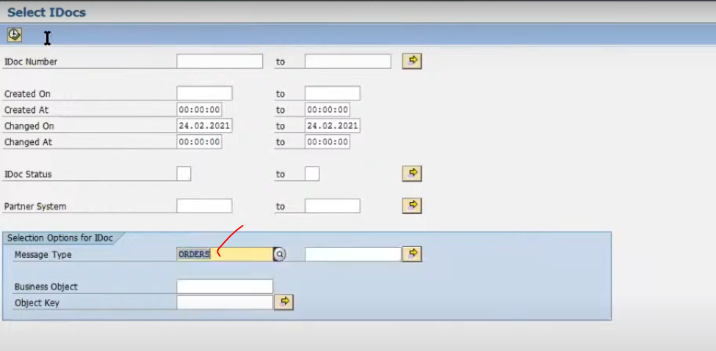
* To find the some of the IDOCS
* 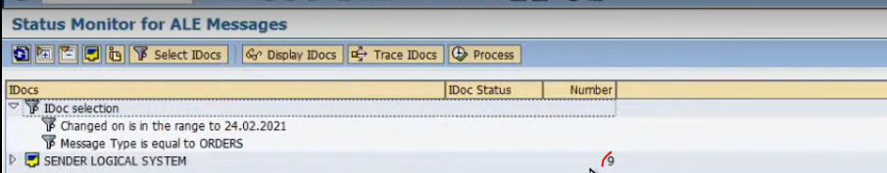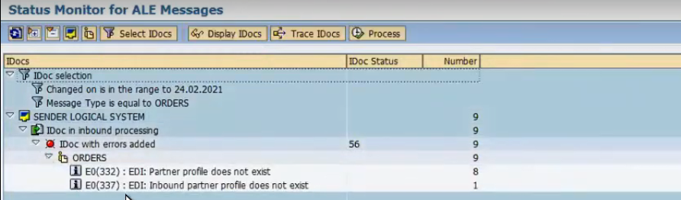

Dbl click on error :

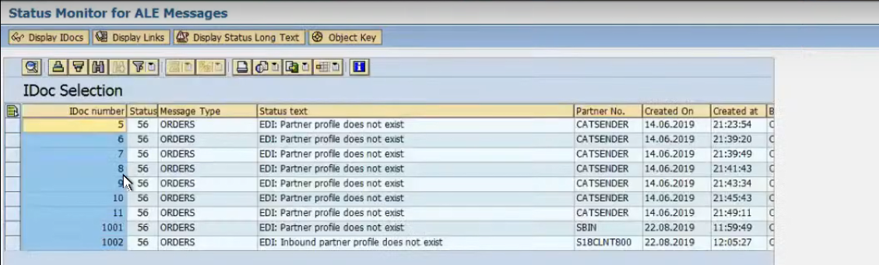

Now we have taken 1001-IDOC—went to error.

Now we are going to we02/we05 🡪 give the IDOC no: 🡪 F8

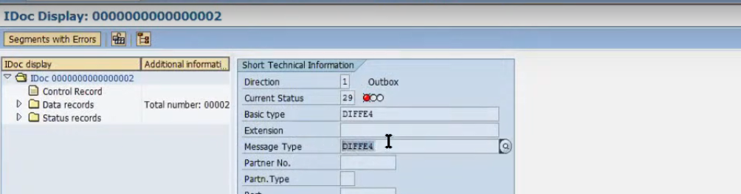 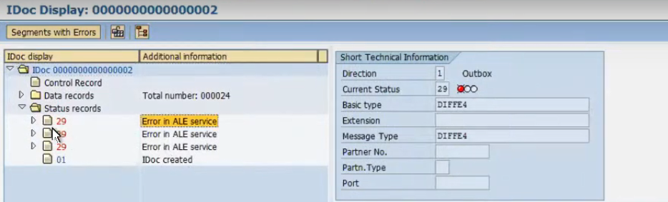

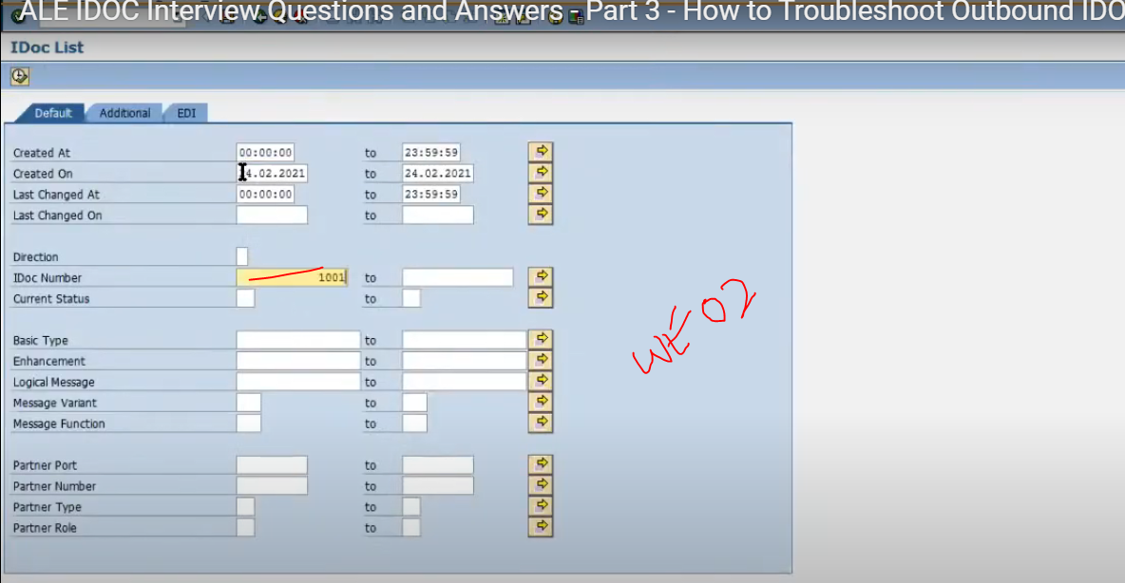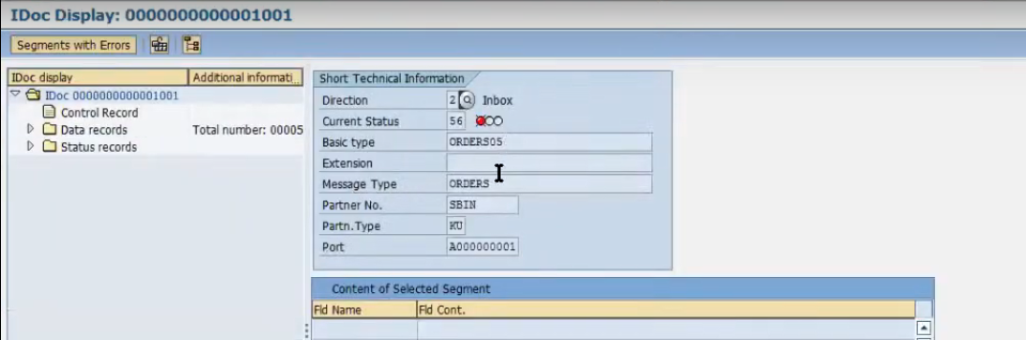

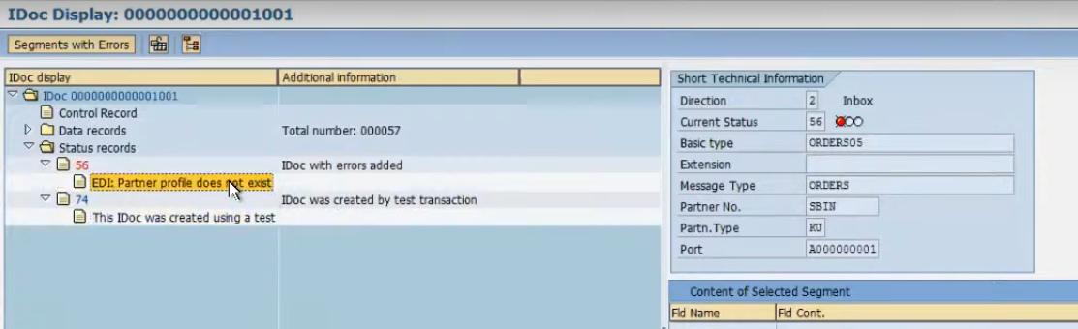

Direction-2 this is inbound idoc we will see later how to trouble shoot

* You can start debugging from here also

INBOUND IDOC:

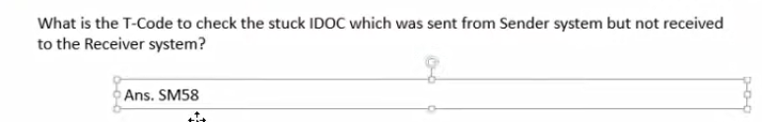

In SM58 it is stuck if you not written any code for commit-work after the MASTER_IDOC_DISTRIBUTE

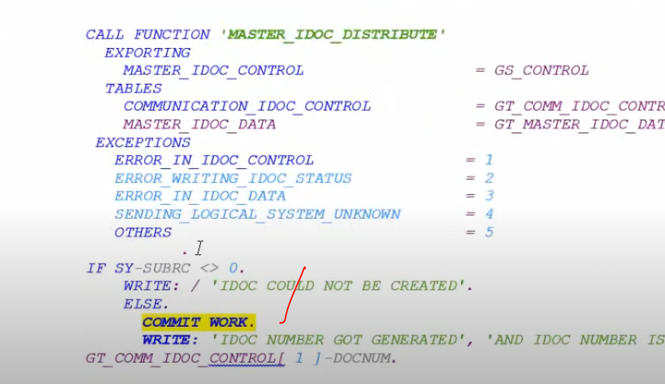

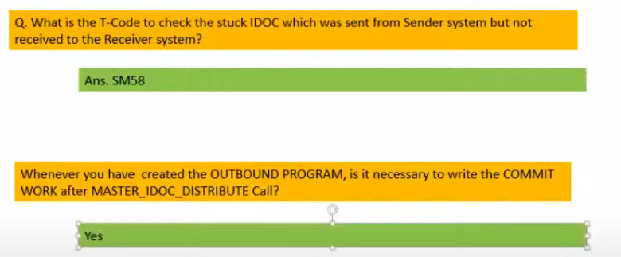

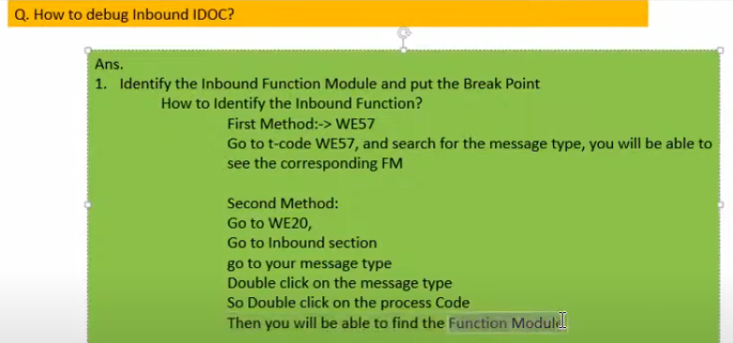

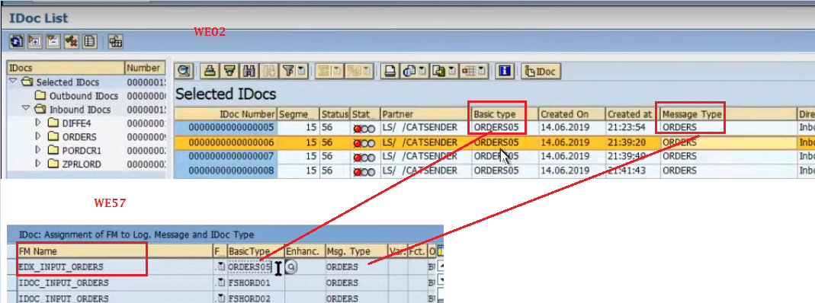

Or

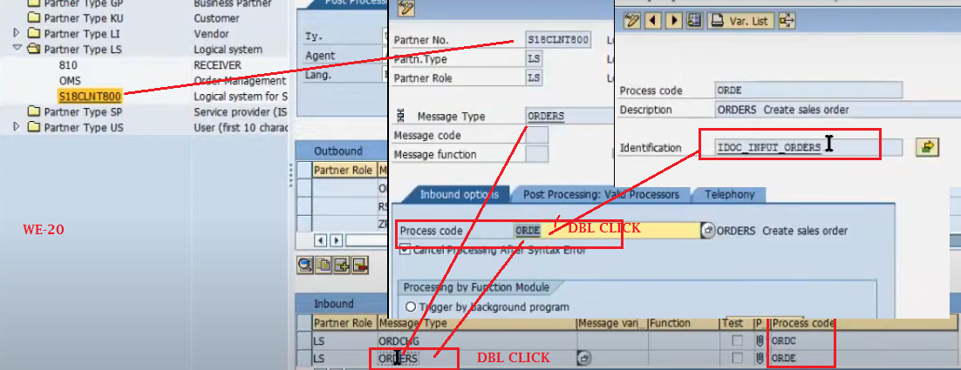

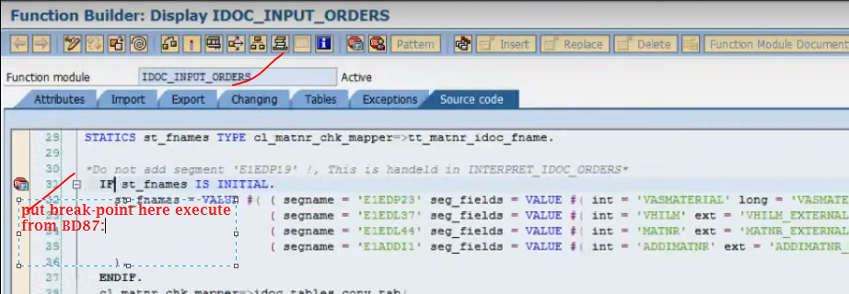

* To debug the inbound function module either you can go with BD87/WE19.
* When you are in QTY/DEV system you can use it WE19/BD87.
* When you are using BD87: IDOC should have the error status. 🡺 you can debug through IDOC No. success idoc you can’t be debug through BD87.
* 
* To find the some of the IDOCS
* 

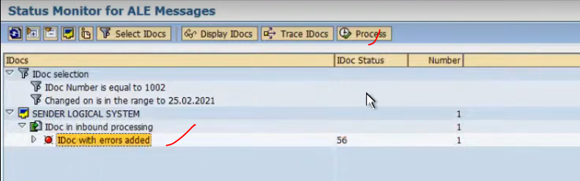



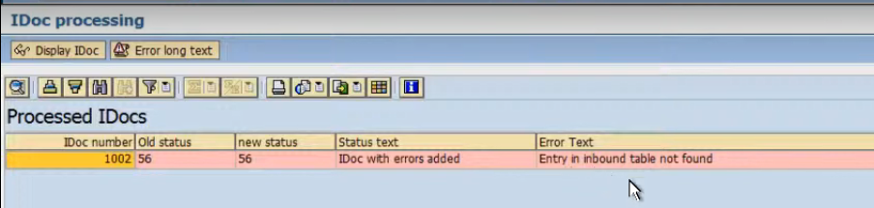

Means of error: It has not triggered the FM, why? Before calling the FM it self some where and some place got problem so it has not reached to The FM.

BD-87 only process the error IDOC only

It has not generate the NEW IDOc.. it is executing from same IDOC.

WE-19

* Is generate te another iDOC once process completed

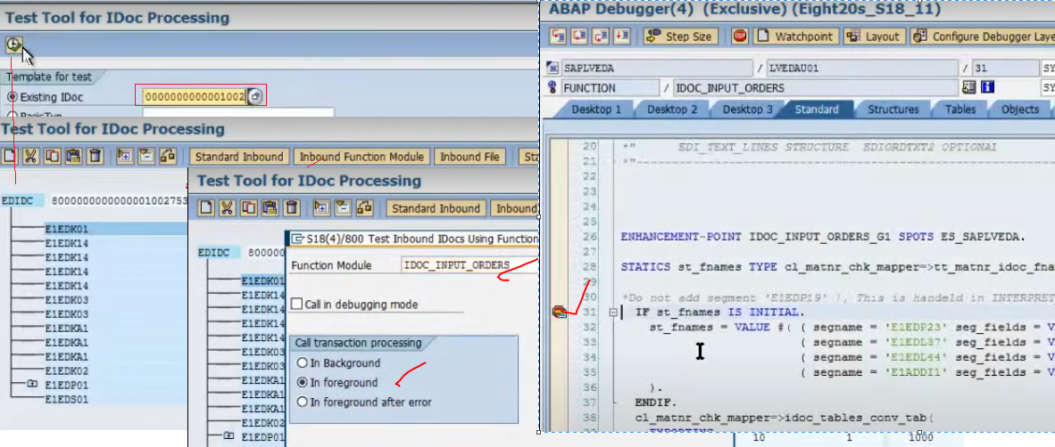

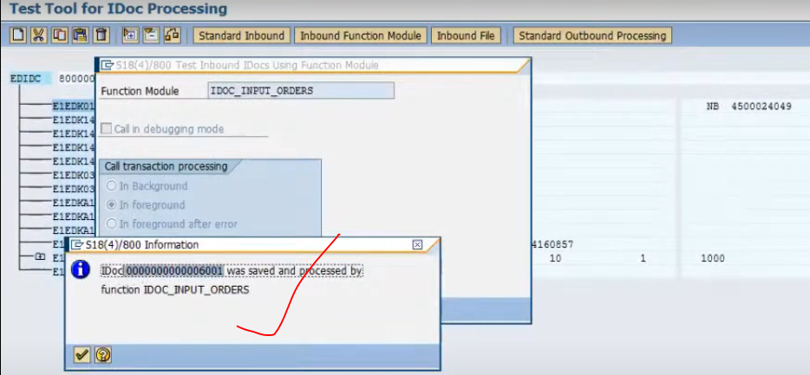

In lower environment we will use the WE-19

In PRD system we will use the BD87

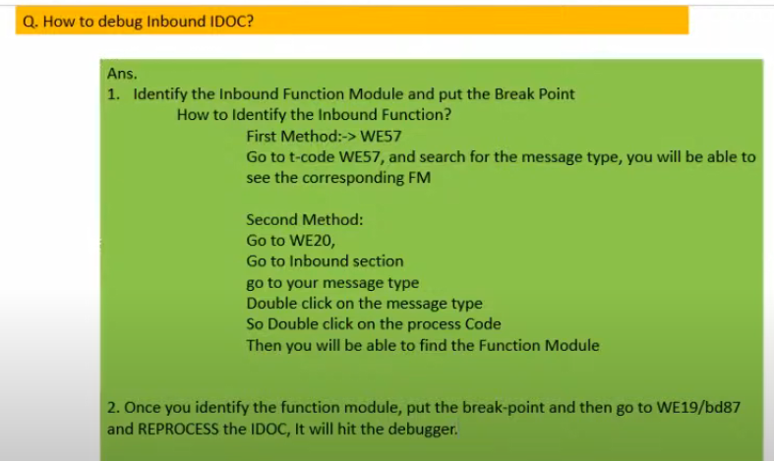

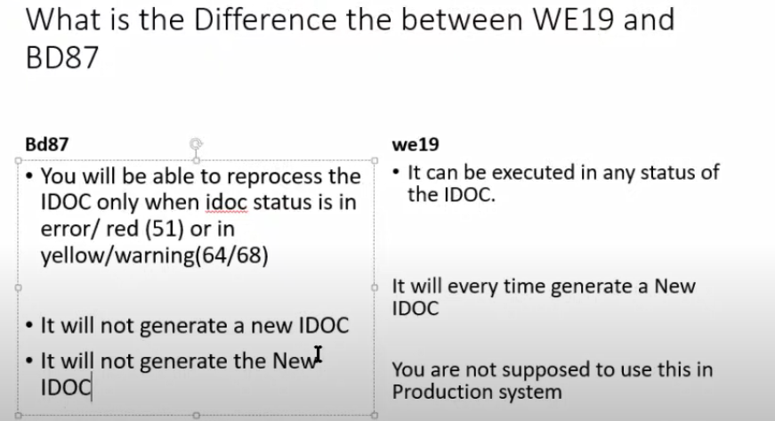

Inp:

Suppose my idoc is in gree status nad I want to debug in PRD?

Ans: in production we can’t use it in WE19, so we need to debug through the BD87 only but BD87 accepts the error idocs.. how to debug? In these case we need to change the status of the idoc, now question is how to change the status of IDOC from green to error.

To change the status use the program: RC1_IDOC_SET_STATUS:

Provide the IDOC No: **********

OLD status: 51

New status: 68

Press F8

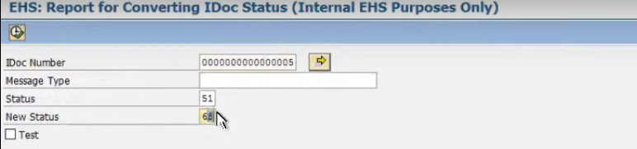

This is only for changing the status only..

Message Control:

